

TEMENOS T24

Stream

User Guide

Table of Contents

Back Button Widget <Code>

Introduction 3

Preface 3

Overview 3

Prerequisites 3

The supported platforms are: 3

Assumptions 3

Getting Started 3

Installation 3

Adding the Back Button Widget 3

# 

# Introduction

## Preface

This User Guide is intended for Developers and provides the step by step instructions for adding a new custom button called ‘Back’ button, in your presentation.

## Overview

This Back button widget overrides the default back-button behaviour and registers an event listener for the back button event with an Edge button.

## Prerequisites

## The supported platforms are:

* Android
* BlackBerry WebWorks (OS 5.0 and higher)
* Windows Phone 7 and 8

## Assumptions

It is assumed that you are familiar with the edgeConnect Editors and have working knowledge on edgeConnect.

# Getting Started

## Installation

For installation:

1. Copy the **com.temenos.widgets.hybrid.events.backbutton** folder in your widgets folder (Ex: /{your project/templates }).
2. Copy the content of **Insert in widget.xml** in your widget.xml file within your project.
3. Make sure the **cordova_loader.js** file is inserted in your template header for the phase where you want to use the **Back Button** widget.

Insert ***<script src="$$HTML_LOCATION$/js/cordova/cordova_loader.js"></script>*** in your header TPL.

## Adding the Back Button Widget

To add the Back button:

1. In the **Presentation Editor**, create the button and double-click it. The **Presentation Button Properties** dialog appears.
2. Navigate to the tabs **Appearance** -> **Button.**
3. For the **Display Type** field, select **com.temenos.widgets.hybrid.events.backbutton**.
4. In **Widget Details** tab, you have to set up the widget settings.

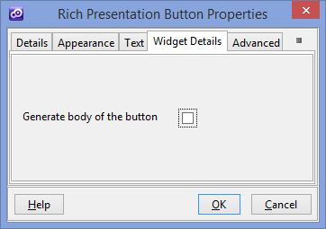

1. For **Generate body of button**, enable or disable the generation of the body of the button.

This creates a relationship between the device Back button and an Edge button.